Assignment 3

Submit a file called Assignment3.zip which contains:

* MaxInt.java
* Fraction.java
* Seconds.java
* Seconds2.java

Additional marking scheme:

-5 for any of the following:

* Compiler gives a warning.
* Constants are not used where appropriate. Constanst MUST be defined and used in 3 of the questions.
* Constants are incorrectly formatted

-20 if casting is not used in question 2.

# question 1

Write a program called MaxInt.java which first defines two int constants. They contain the largest/smallest possible int values. Print their values. Then, add 1 to the largest value and subtract 1 from the smallest value. Print the results. Don’t just output 4 numbers. Include a short description for each one.

# Question 2

Write a program called Fraction.java which requests the user to enter a numerator and denominator for a fraction. Both are int’s. Use casting to display the fraction as a double.

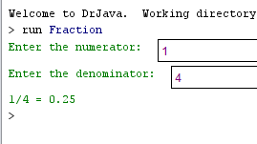

# Question 3

PP2.8 on p. 109. Call the program Seconds.java.

Write a program that reads values representing a time duration in hours, minutes, and seconds and then prints the equivalent total number of seconds. (For example, 1 hour, 28 minutes, and 42 seconds is equivalent to 5322 seconds.)

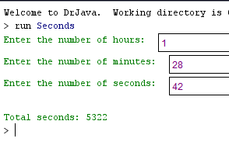

# Question 4

PP 2.9 on p. 109. Call the program Seconds2.java.

Create a version of the previous project that reverses the computation. That is, read a value representing a number of seconds, then print the equivalent amount of time as a combination of hours, minutes, and seconds. (For example, 9999 seconds is 2 hours, 46 minutes, and 39 seconds.)

